|  |  |
| --- | --- |
| **Reg No: 2212406**  **Name: M.Rayyan Aamir** | **Assignment # 2**  **Date: 21-10-2025** |

|  |  |  |  |
| --- | --- | --- | --- |
| Program | : BSCS | Class & Section | : BSCS 6A |
| Course Name | : Android Application Development |  |  |
| Instructor’s Name | : Muhammad Azhar | Marks | : **/4** |

**(CLO-2)**

The purpose of this assignment is to enhance your understanding of Android UI design and activity navigation. You will build upon a base Android project by implementing complete login functionality and extending the app with additional screens, interactions, and navigation flows.

**Base Project:**  
You can access the base Android project from the following GitHub repository:

[https://github.com/Azzzhar7/android-login-app](https://github.com/Azzzhar7/android-login-app" \t "_new)

This starter project provides a simple login interface implemented using Java and XML in Android Studio. You are required to extend the existing app by completing and improving its functionality as follows:

1. Complete Login Implementation
   * Use hard-coded credentials (e.g., username and password) for authentication.
2. Add New Screens (Activities)
   * Registration Page: Allow users to create a new account.
   * Forget Password Page: Enable users to retrieve or reset their password.
   * Reset Password Page: Provide functionality to update the password.
   * Landing Screen (Home Page): Displayed after a successful login, showing a simple welcome message or dashboard.
3. Implement Navigation and Redirection
   * Use Intents to navigate between activities.
   * After a successful login, redirect the user to the Landing Screen.
   * Add buttons or clickable text links for “Register” and “Forgot Password” on the login screen for easy navigation.

**Submission Requirements:**

* Push your completed project to your own GitHub repository.
* Include a short README file describing the added features and navigation flow.
* Prepare screenshots of your project code from android studio, output from emulator or separate device, and your git repository to include in your submission document.

HOME PAGE :

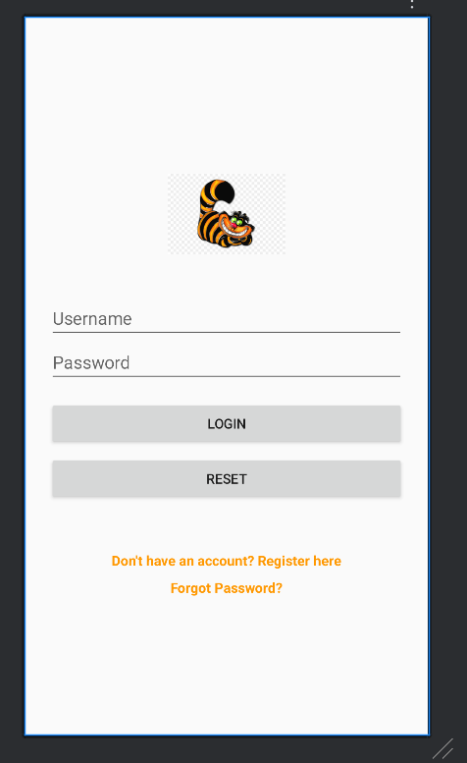

REGISTRATION :

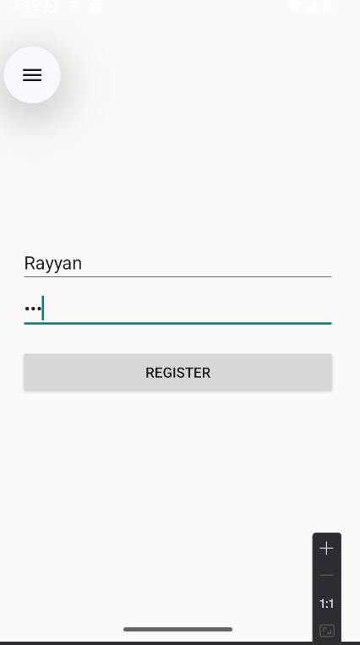

LOGIN PAGE :

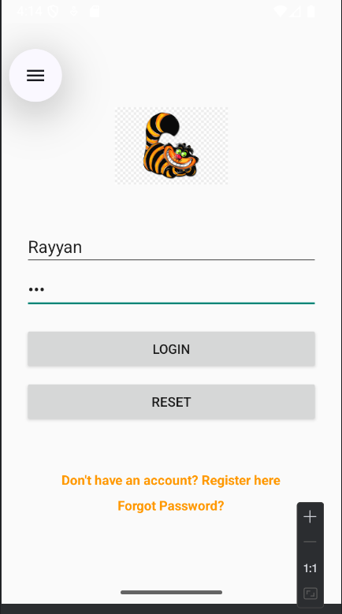

WELCOME PAGE :

